******DOMINICAN COLLEGE OF TARLAC**

Mac Arthur Highway, Poblacion (Sto.Cristo), Capas. 2315 Tarlac, Philippines

Tel.No. (045) 491-7579/Telefax (045) 925-0519

E-mail: domct _2315@yahoo.com

**COLLEGE DEPARTMENT**

A.Y. 2020-2021, First Semester

*OBE FACULTY-DESIGNED MODULE*

**THE CONTEMPORARY WORLD**

**(GE3)**

**I. Subject:** GE3 - The Contemporary World

**II. Learning Outcomes:**

1. Narrate a short history of global market integration in the twentieth century.

2. Identify the attributes of global corporations.

**III. Topic/Lesson:** History of Global Market Integration

**IV. Days of Learning Sessions:**

|  |  |  |
| --- | --- | --- |
| *Section* | *Modular* | *Online* |
| BEED 3A | Wednesday | Friday |
| BEED 3B | Thursday | Saturday |
| BSED E3A | Saturday | Saturday |
| BSED E3B | Saturday | Saturday |
| BSED M3A | Thursday | Saturday |

**V. Expected Outcome:**

Explain the origin of global market integration.

**VI. Delivery:**

MODULE 6

History of Global Market Integration

MOTIVATION PHASE



Activity 1

The Start of Working Together

Answer the question below.

Before the rise of today’s modern economy, people only produced for their family. Nowadays, economy demands the different sectors to work together in order to produce, distribute, and exchange products and services.

What do you think caused this shift in the way people produce for their needs?

***I believe the cause of shifting the way people from their needs because of poverty.***

PRESENTATION PHASE

**History of Global Market Integration**

In order to understand this shift in the way people produce for their needs, we will be going back in time, 12,000 years ago.

**The Agricultural Revolution and the Industrial Revolution**

The first big economic change was the **Agricultural Revolution** (Pomeranz, 2000). When people learned how to domesticate plants and animals, they realized that it was much more productive than hunter-gatherer societies. This became the new agricultural economy. Farming helped societies build surpluses, meaning, not everyone had to spend their time producing food. This, in turn, led to major developments like permanent settlements, trade networks, and population growth.

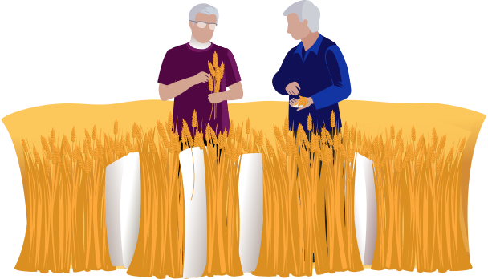

The second major economic revolution is the **Industrial Revolution** of the 1800s. With the rise of industry came new economic tools, like steam engines, manufacturing, and mass production. Factories popped up and changed how work functioned. Instead of working at home where people worked for their family by making things from start to finish, they began working as wage laborers and then becoming more specialized in their skills. Overall, productivity went up, standards of living rose, and people had access to a wider variety of goods due to mass production.

However, every economic revolution comes with economic casualties. The workers in the factories—who were mainly poor women and children—worked in dangerous conditions for low wages. As a result, nineteenth-century industrialists were known as robber barons—with more productivity came greater wealth, but also greater economic inequality. In the; late nineteenth century, labor unions began to form. These organizations of workers sought to improve wages and working, conditions through collective action, strikes, and negotiations. Inspired by Marxist principles, labor unions gave way for minimum wage laws, reasonable working hours, and regulations to protect the safety of workers.

**Capitalism and Socialism**

There were two competing economic models that sprung up around the time of the Industrial Revolution, as economic capital became more and more important to the production of goods. These were capitalism and socialism.

**Capitalism** is a system in which all-natural resources and means of production are **privately owned.** It emphasizes profit maximization and competition as the main drivers of efficiency. This means that when one owns a business, he needs to outperform his competitors if he is going to succeed. He is incentivized to be more efficient by improving the quality of one's product and reducing its prices. This is what economist Adam Smith in the 1770s called the “invisible hand” of the market. The idea is that if one leaves a capitalist economy alone, consumers will regulate things themselves by selecting goods and services that provide the best value.

Whereas, government plays an. even larger role in **socialism.** In a socialist system, the means of production are under collective ownership. It rejects capitalism’s private property and hands-off approaches. Instead, in socialism, property is owned by the **government** and allocated to all citizens, not only those with the money to afford it. Socialism emphasizes collective goals, expecting everyone to work for the common good and placing a higher value on meeting everyone’s basic needs than on individual profit. When Karl Marx first wrote about socialism, he viewed it as a stepping stone toward communism, a political and economic system in which all members of a society are socially equal.

**The Information Revolution**

Ours is the time of the information revolution. Technology has reduced the role of human labor and shifted it from a manufacturing-based economy to one that is based on service work and the production of ideas rather than goods. This has had a lot of residual effects on our economy. Computers and other technologies are beginning to replace many jobs because of automation or outsourcing jobs offshore. We also see the decline in union membership. Nowadays, most unions are for public sector jobs, like teachers.

The service industry includes every job such as administrative assistants, nurses, teachers, and lawyers. This is a big and diverse group because the tertiary sector, like all the economic sectors we have been discussing, is defined mainly by what it produces rather than what kinds of jobs it includes. Sociologists have a way of distinguishing between types of jobs, which is based more on the social status and compensation that come with them. These are the primary labor market and the secondary labor market.





The **primary labor market** includes jobs that provide many benefits to workers, like high incomes, job security, health insurance, and retirement packages. These are white-collar professions, like doctors, accountants, and engineers.



**Secondary labor market** jobs provide fewer benefits and include lower-skilled jobs and lower-level service sector jobs. They tend to pay less, have more unpredictable schedules, and typically do not offer benefits like health insurance. They also tend to have less job security.

**Global Corporations**

The increase in international trade has both created and been supported by international regulatory groups, like WTO, and transnational trade agreements, like NAFTX. There is not a single country that is completely independent. All are dependent to some degree on international trade for their own prosperity. Without international trade, there would be no need for international regulatory, groups. Without the international regulatory groups, international trade at the current massive scale would be impractical. The trade regulatory groups and agreements regulate the flow of goods and services between countries. They reduce tariffs, which are taxes on imports, and make customs procedures easier. This makes trading across national borders rich more feasible.

These international trade agreements often benefit private industries the most. Companies can produce their goods and services across many different countries. For instance, you can have a backpack that was designed in the United States but the materials came from China, and it was put together in Mexico before it was shipped back to the United States to be sold.

These companies that extend beyond the borders of one country are called **multinational or transnational corporations (MNCs or TNCs).** They are also referred to as **global corporations.** They intentionally surpass national borders and take advantage of opportunities in different countries to manufacture, distribute, market, and sell their products. Some global corporations are ubiquitous, like McDonald’s or Coca-Cola, and yet, they still market themselves as American companies. Others can be surprising like General Electric, which is based in the United States but has more than half of its business and employees working in other countries. Another example is Ford Motor Company, the classic 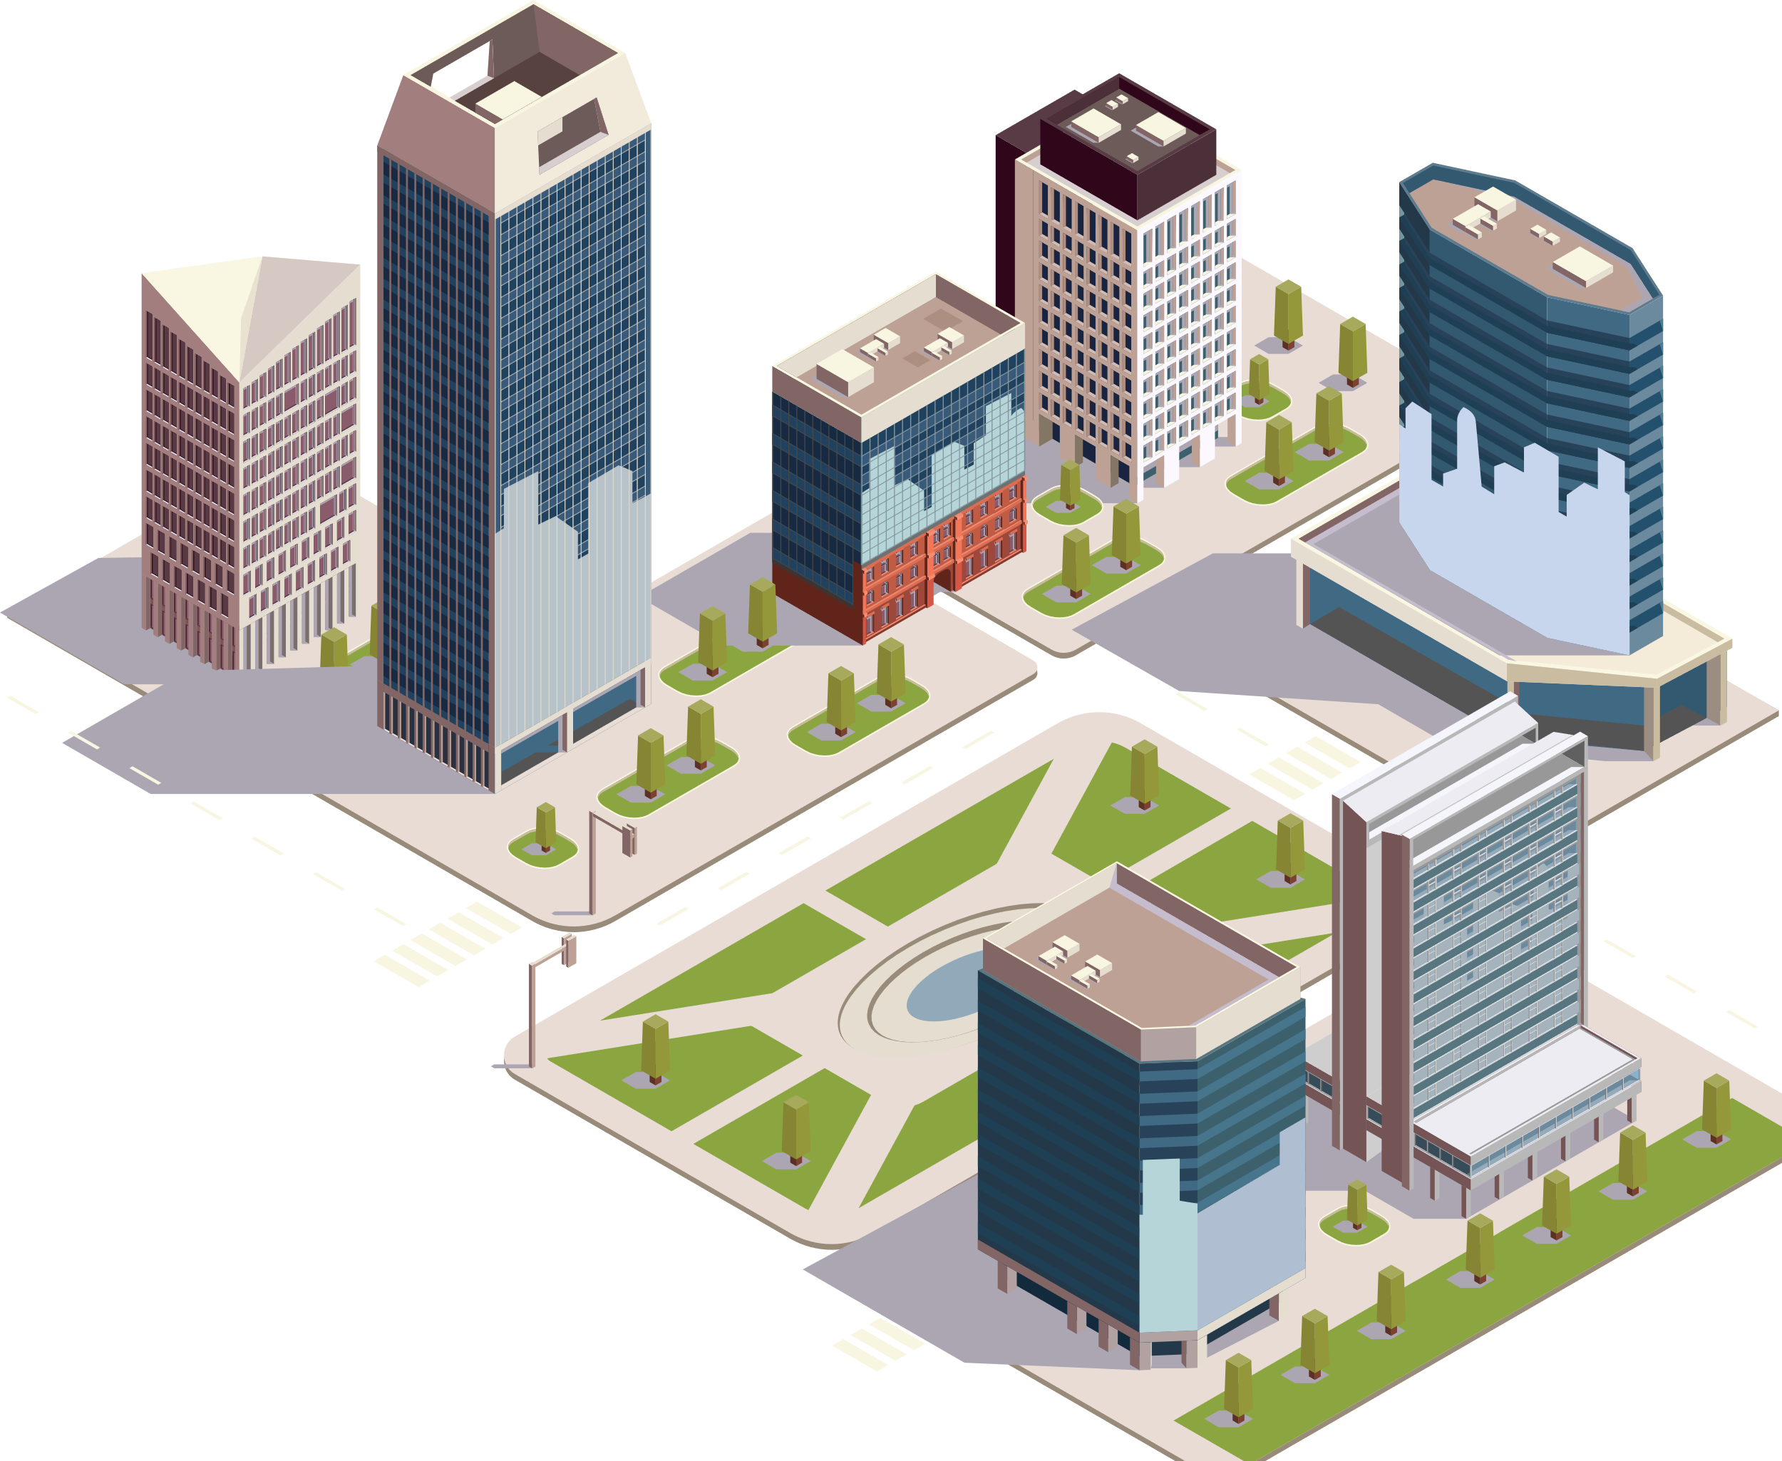American car company, headquartered in Michigan that manufactures cars worldwide.

Transnational corporations have a significant role in the global economy. Some have greater production advantages than an entire nation. They influence the economy and politics by donating money to specific political campaigns or lobbyists. They can even influence the global trade laws of the international regulatory groups.

Global corporations often locate their factories in countries which can provide the cheapest labor in order to save up for expenses in the making of a product. As a result, developing nations will provide incentives, like tax-free trade zones or cheap labor. The companies will set up shop in their country in hopes of bringing jobs and industry to beleaguered agricultural areas. This promotes more rapid advances in the developing nation because of the ideas and innovations brought over from the industrialized nations. It also makes nations around the world more interdependent, which minimizes the potential for conflict.



Activity 2

Analysis

Answer the following questions.

1. What are the effects of the information revolution in today's global market?

_____________________________________________________________________________

_____________________________________________________________________________

_____________________________________________________________________________

_____________________________________________________________________________

_____________________________________________________________________________

_____________________________________________________________________________

_____________________________________________________________________________

_____________________________________________________________________________

_____________________________________________________________________________

_____________________________________________________________________________

_____________________________________________________________________________

2. What are the effects of multinational corporations in the Philippine economy?

_____________________________________________________________________________

_____________________________________________________________________________

_____________________________________________________________________________

_____________________________________________________________________________

_____________________________________________________________________________

_____________________________________________________________________________

_____________________________________________________________________________

_____________________________________________________________________________

3. Analyze socialism and capitalism in relation with the Philippine society. Which of these economic systems would work in our country?

_____________________________________________________________________________

_____________________________________________________________________________

_____________________________________________________________________________

_____________________________________________________________________________

_____________________________________________________________________________

_____________________________________________________________________________

_____________________________________________________________________________

_____________________________________________________________________________

_____________________________________________________________________________

_____________________________________________________________________________

_____________________________________________________________________________



Activity 3

Abstraction

Answer the following questions.

1. Analyze the “global” nature of multinational corporations.

_____________________________________________________________________________

_____________________________________________________________________________

_____________________________________________________________________________

_____________________________________________________________________________

_____________________________________________________________________________

_____________________________________________________________________________

_____________________________________________________________________________

_____________________________________________________________________________

_____________________________________________________________________________

_____________________________________________________________________________

_____________________________________________________________________________

2. Do you think the positive effects of multinational corporations outweigh the negative effects? Why or why not?

_____________________________________________________________________________

_____________________________________________________________________________

_____________________________________________________________________________

_____________________________________________________________________________

_____________________________________________________________________________

_____________________________________________________________________________

_____________________________________________________________________________

_____________________________________________________________________________

_____________________________________________________________________________

_____________________________________________________________________________

_____________________________________________________________________________

3. What do you think are the ways to lessen, if not eliminate, the negative consequences of multinational corporations?

_____________________________________________________________________________

_____________________________________________________________________________

_____________________________________________________________________________

_____________________________________________________________________________

_____________________________________________________________________________

_____________________________________________________________________________

_____________________________________________________________________________

_____________________________________________________________________________

_____________________________________________________________________________

_____________________________________________________________________________

_____________________________________________________________________________



Activity 4

Weighing the Market

The history of global market brought positive and negative effects through time. At this point, markets will be assessed through your own perspective provided that you already had a good grasp of the different concepts in economic and financial globalization. This activity will help you understand the benefits and harms of global economic processes, structures, and technologies.

1. Listed below are the scenarios that have to do with the economy. In pairs, discuss the major impacts of these scenarios whether they are positive or negative (for you, for the country, or for the Filipinos). The “Case-by-Case” column can be used to justify your answers.

|  |  |  |  |
| --- | --- | --- | --- |
| **Scenario** | **Positive** | **Negative** | **Case-by-Case** |
| **A** |  |  |  |
| **B** |  |  |  |
| **C** |  |  |  |
| **D** |  |  |  |
| **E** |  |  |  |

**Scenario A:** Agriculture is the main source of employment in your home province. The government has recently decided to develop the farmlands into real estate and exclusive subdivisions in order to attract foreign investors to the country.

**Scenario B:** You decided to purchase a new shirt through an online shop based in London.

**Scenario C:** The Philippine government is being pressured by the current economic crisis to import rice from Taiwan and other nearby countries in the region.

**Scenario D:** A multinational corporation decided to close. Unfortunately, your father is one of its many employees whose work has been terminated. However, he could still be employed if he were to accept the offer to move or relocate to another country.

**Scenario E:** The global financial crisis has affected the investment funds of your mother that she can use for her retirement.

2. How did you decide for each scenario? What are the pros and cons that you list down before you came up with the final judgment? Share with the class your responses to each scenario.

_____________________________________________________________________________

_____________________________________________________________________________

_____________________________________________________________________________

_____________________________________________________________________________

_____________________________________________________________________________

_____________________________________________________________________________

_____________________________________________________________________________

_____________________________________________________________________________

_____________________________________________________________________________

ASSESSMENT PHASE

*See Schoology.*

**REFERENCE:**

Aldama, P. (2018). *The contemporary world.* Manila, Philippines: Rex Book Store.

Photos: Freepik